Aggregate Functions Practice in Power Bi
- Aggregate And Time Intelligence Expressions Of DAX functions:
- SUM(),
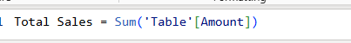
Q1: Calculate Total sales

Q2: Calculate Total Sales of Product A in current year

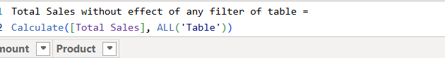
Q3: Calculate Total Sales not effected by any filter :

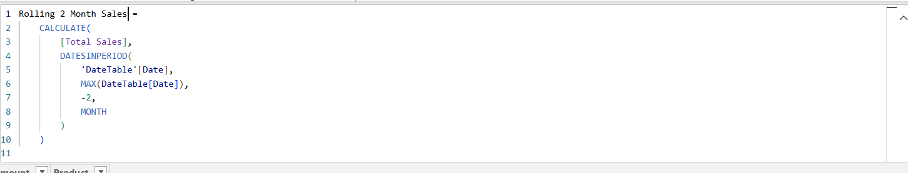
Q4: Calculate Total Sales of past three months from current date.
Q5: Calculate Total Sales of rolling two months
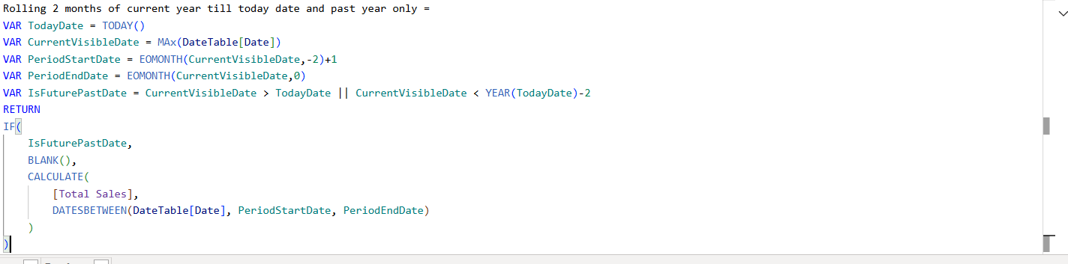
Q6: Calculate Total Sales of rolling two months only past one year and current year till today date:
Q7: Average Rolling Total Sales of two months past one year and current year till today date:
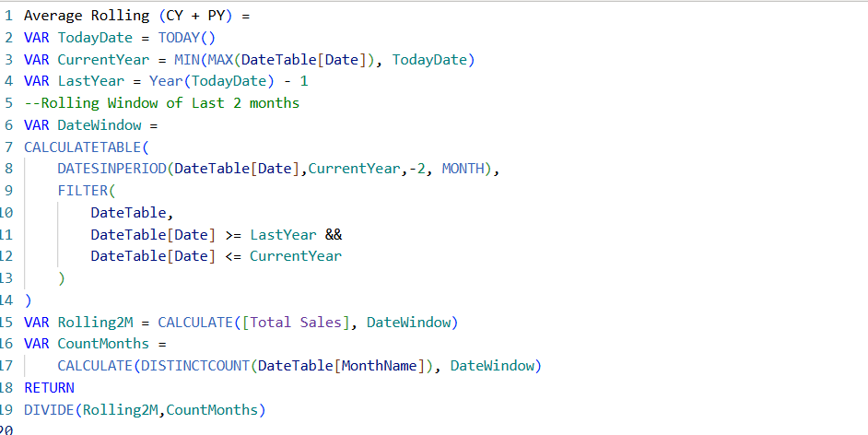

Dashboard for Visualization
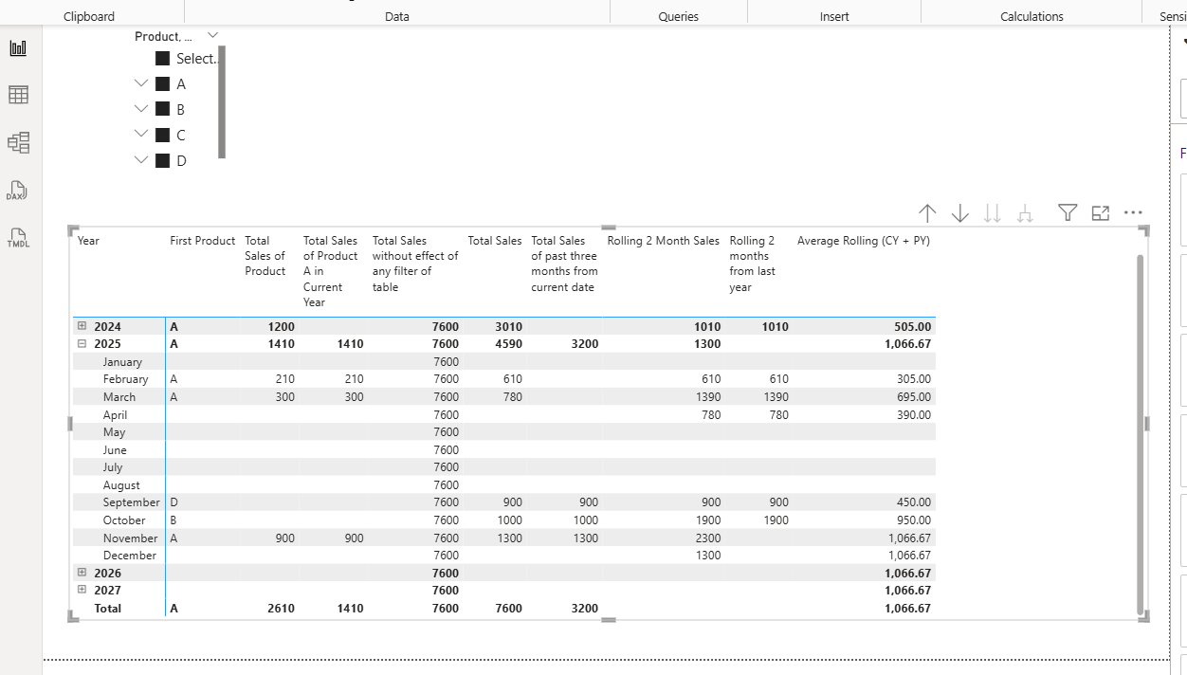
Q7: Current Year Cumulative total sales till today
Q8: Last 1 year Cumulative total sales till today
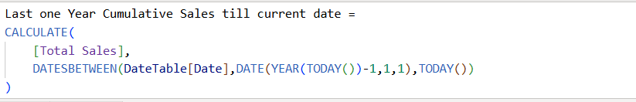
Q9: Cumulative sum Monthly basis
Q10: YoY Growth percentage
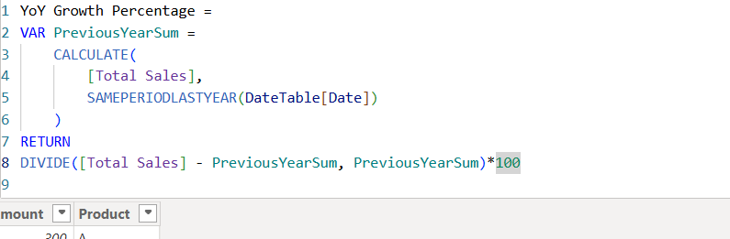
Dashboard Visualization
